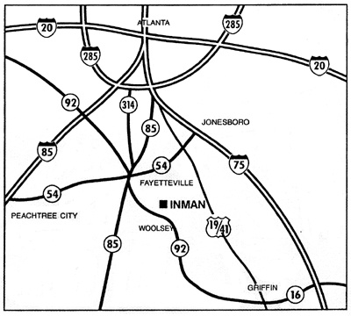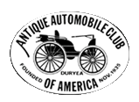

**FREE ADMISSION &**

**NO REGISTRATION**

**FEES!**

**8th Annual**

** same location as Inman Farm Heritage Days **

**\* LUNCH SOLD**

**\* RESTROOMS AVAILABLE**

PARKING ON GRASS

**Contact:**

Rick & Joanne Minter

Stephanie Adamek

283 Hill’s Bridge Rd

Fayetteville, GA 30215

stephanie@mintersfarm.com

770-461-2840

www.mintersfarm.com

PICK-UPS & TRACTOR TRAILERS WELCOME

Contact:

Joe Scott 770-227-0450

(cell) 770-876-0260

Howell Fowler 770-227-1850

Kenneth 770-227-0118

***Trophy for Best in Show***

***&***

***$50 Gift Certificates from Bumper to Bumper Auto Parts for Class Winners***

***For AACA Car Show Only***

***1st 50 cars receive dash plaques***

**50/50**

**RAFFLE**

Registration open from 9:00 - 12:00

for cars 25 years or older

**Griffin Piedmont Region**

Antique Car Show

**Inman Antique Truck Show**

Come & see the kind of trucks

your parents & grandparents

worked & farmed with

***rusty and dusty trucks***

***more than welcome***

**8th Annual**

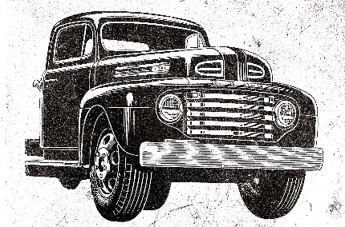

Saturday, June 17, 2017

Inman Antique Truck Show

Old Fashion Truck Show, Car Show & Auction

***Awards for:***

***Best Truck in Show***

***Most Original Truck***

***Best Rusty Truck (running)***

***Promoter’s Choice***